Steps for running weather applications:-

To compile and test the application:

Create the jar file if using gradle follow below steps

Step 1 - Open terminal/CD prompt

Step 2 - copy the project from GitHub to ur folder

Step 3 - go to cd prompt and go to the directory where you copied the project

Step 4 - run - gradle clean assemble -- this will create a jar file in build folder, go to builder and then to lib and copy that jar

Step 5 - if Hadoop is installed please run below command

/bin/spark-submit --class practice.ambiata_task --master local <jar file name>

Else if gradle is not installed

Please download the jar file from the project in the GitHub.

And directly run the jar file using below command

/bin/spark-submit --class practice.ambiata_task --master local base-engine-1.0-SNAPSHOT

In this case jar file name is base-engine-1.0-SNAPSHOT.jar

Else

Copy the code directly to eclipse, then right click on the project, go to the property and select scala compiler and change the scala installation to 2.10 bundleSteps for running weather.

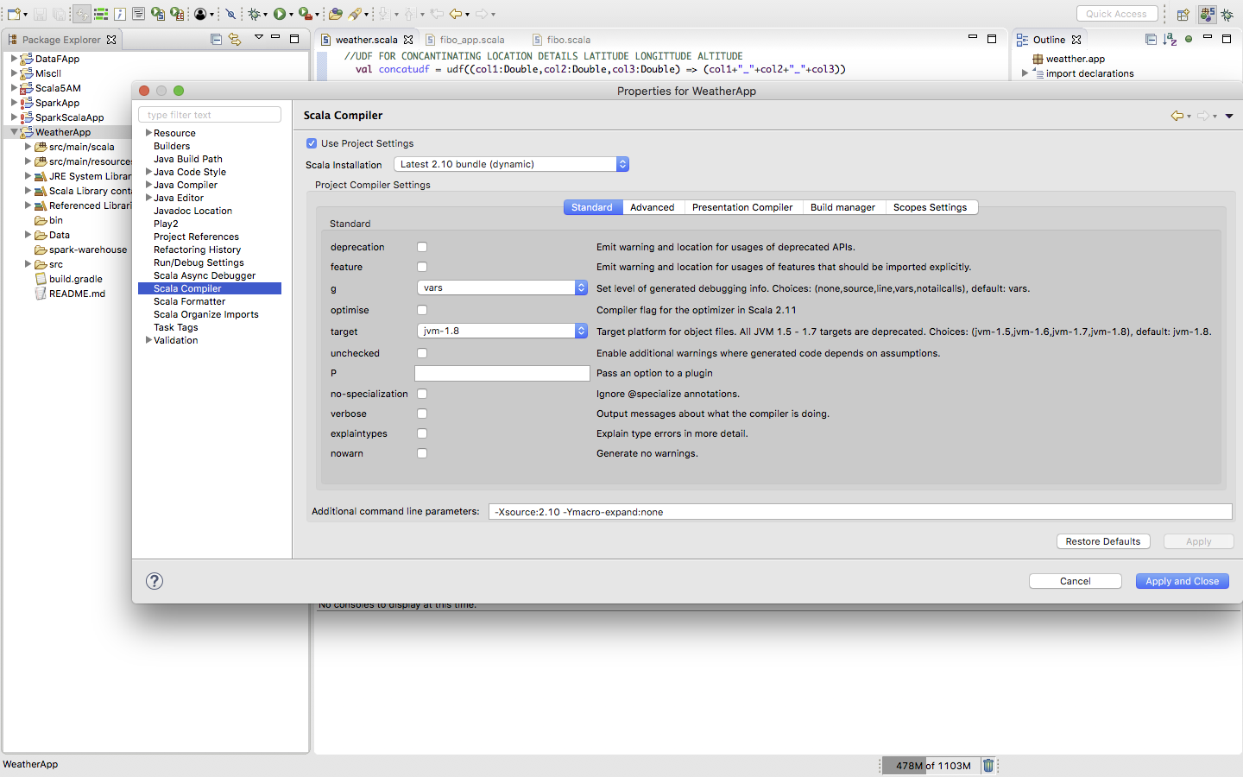

Scala Compiler 2.10 bundlE

And Run the application as Run as Scala application

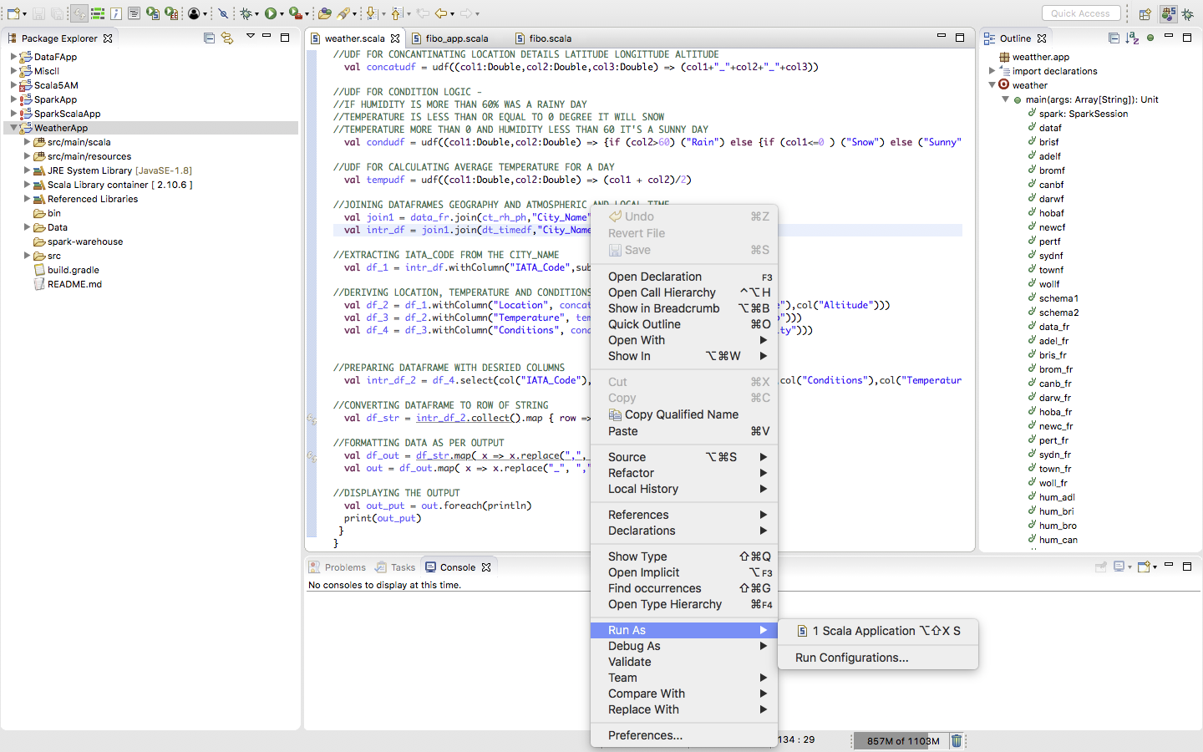

Type to enter a caption.